Department of Internal Affairs
Information Architecture Report

Release date: 15 July 2012
Prepared by: Dave O'Brien
Version no: 2

Optimal Usability Limited
Level 2
126 Cuba Street
Wellington 6011
New Zealand

http://www.optimalusability.com

TABLE OF CONTENTS

EXECUTIVE SUMMARY 3
PURPOSE 4
METHOD 4
CARD SORTING 8
TREE TESTING 11
PROPOSED SITE STRUCTURE 15
IA PRINCIPLES 16

EXECUTIVE SUMMARY

In June 2012, the Department of Internal Affairs commissioned work to research, develop, and document an information architecture to support the redevelopment of newzealand.govt.nz.

We conducted 1 card sort to reveal how users categorise government content, and 2 rounds of tree testing to evaluate the findability of that content in several proposed site structures.

Card sorting: When sorting 43 “cards” of typical government content into groups:
- Participants created an average of 10 groups.
- The groups were overwhelmingly topic-based (e.g. jobs, health, education, etc.).
- All segments (by job, age, location, etc.) chose similar groupings, suggesting that a single site structure would work for most site visitors.

Tree testing: When searching through various site structures looking for typical content:
- Vague topics like “Social welfare & support” and “About New Zealand” attracted many unwanted clicks.
- Topics that used “brand names” (e.g. “Heartlands”) without describing them (e.g. “Heartlands (rural access to government services)” caused problems.
- The top-level “Consumer affairs” topic worked better than putting it under other topics such as Money & Tax.
- Participants were split between being topic-focused (e.g. go to Passports, then look for a way to complain) and action-focused (look for Complaints right from the start).
- For tasks involving legislation (looking up laws and codes), Crime & Justice is the magnet topic.
- For tasks involving anything local (e.g. a proposed motorway, accessible parking), participants looked for local government, in both the Contact Government section and in the Community, Arts, & Recreation section.
- In several sections (e.g. Environment), the third level was too abstract for many participants.

Based on these studies of different approaches to site organisation, a revised version of the “straw man” tree emerged as the top-performing structure – see page 16.

During design and testing, the following general principles also emerged:

- Organise mainly by topic.
- Define the top 2 levels.
- Consider the order of topics.
- Aim for 4-10 topics at lower levels.
- Avoid general or ambiguous terms.
- Avoid (or explain) brand names.
- Make every word earn its keep.
- Put content where most people look for it, but provide a safety net.

PURPOSE
The Department of Internal Affairs (DIA) is planning to redevelop the newzealand.govt.nz website, to provide all-of-government information online in a customer-centric, easy-to-use manner based on customer needs, not the structure of government.

Part of this redesign is the information architecture – how users find the information they’re looking for. The new design must ensure that users can:
- Search successfully, using familiar everyday keywords (not necessarily government terms)
- Browse successfully, using categories that are clear and distinguishable to them
- Find information efficiently, on their first visit and on subsequent visits.

METHOD
We used card sorting to generate ideas for organising the new site, used these ideas to design several alternative site structures, and finally tree-tested the respective structures.

Card sorting
We conducted an “open” card sort, where participants were asked to sort 43 cards into groups that made sense to them, and then label the groups themselves.

The 43 cards were representative content taken from both the existing site and the “straw man” proposed site structure.

After an internal pilot study and revisions, ads were placed on newzealand.govt.nz and other related government sites, offering a prize draw for a $100 gift card. This attracted 122 participants – half from government, half not, with a range of locations inside and outside NZ, a range of ages, and a range of frequency of use of government websites.

Participants were also asked to sign up for future studies. More than half did, which suggests substantial public interest in improving this site.

For the results of the card sort, see page 6.

Designing alternative site structures
Based on the results of card sorting, we created several trees to test different organisational ideas and labels, including:
- An “exhaustive” tree that attempted to cover all government topics
- A “minimal” tree that covered only the top content used or requested by existing site visitors
- Revisions of the “straw man” tree, which covered most (but not all) content needed by the public

Each tree was created in a spreadsheet, with questions, issues, and comments added to an adjacent column.

Tree testing

Round 1
In the first round of tree testing, we tested the following site structures:
- The “baseline” tree using the existing site’s topics
- The “straw man” tree developed just before this study
- An “exhaustive” tree developed for this study to test the feasibility of a large structure with full coverage of all government topics.

Each tree contained 3 levels of nested topics, with no other explanatory text.

The tasks were chosen to be representative, realistic, and to cover most major topics:
- You received poor service when you applied for a passport, and you want to tell someone about it.
- Your child uses a wheelchair. Can you get financial support for this?
- You'd like to help maintain tramping trails in your spare time.
- Find out how to protect your holiday home from earthquakes.
- You're having a baby. What are the rules for taking time off?
- Your landlord wants to evict you with 2 weeks notice. Is this legal?
- You're a Canadian who wants to go to uni in Dunedin. Are there any special residency requirements?
- You want to find out exactly where Waitangi is.
- Who is allowed to use handicapped parking?
- You just saw a really offensive billboard by a well-known company. What are the rules for situations like this?
- You want to find out when your great-grandfather first arrived in NZ.
- You've been selected for jury duty. Do you get paid or compensated somehow for your time?

After an internal pilot study and revisions, ads were placed on newzealand.govt.nz and other related government sites, offering a prize draw for a $100 gift card. An email invitation was also sent to card-sort participants who had volunteered for future studies. This attracted the following, from a range of jobs (government and non-government), and a range of locations inside and outside NZ, ages, and frequency of use of government websites:
- Baseline = 103 participants
- Straw man = 98 participants
- Exhaustive = 99 participants

Participants were also asked to sign up for future studies, with a high response rate.

For the results of the round-1 tree tests, see page 12.

Round 2
We used the findings of round 1 to revise our proposed trees. In round 2, we tested:
- A new version of the “straw man” tree
- A “minimal” tree developed for this study to test the feasibility of a stripped-down structure that covered only the most common and critical government topics.

Each tree contained 3 levels of nested topics, with no other explanatory text.

The tasks were slightly revised from round 1, to clarify some language and test specific differences in the trees:
- You received poor service when you applied for a passport, and you want to tell someone about it.
- Your child uses a wheelchair. Can you get financial support for this?
- You'd like to help maintain tramping trails in your spare time.
- Find out how to reinforce your home in case of earthquakes.
- You're having a baby. Find the rules for taking a break from the office.
- Your landlord wants to evict you with 2 weeks notice. Is this legal?
- You're a Canadian who wants to go to uni in Dunedin. Are there any special residency requirements?
- You're on crutches for a month. Are you allowed to use parking spots marked with a wheelchair?
- You just saw a really offensive billboard by a well-known company. What are the rules for situations like this?
- You want to find out when your great-grandfather first arrived in NZ.
- You've been selected for jury duty. Do you get paid or compensated for your time?
- People are being asked to provide input on a plan for a new motorway. You want to give your opinion.
- Your 2-month-old dishwasher isn't working right, but the store claims there's nothing wrong and refuses to fix it. What are the rules for this?

After an internal pilot study and revisions, ads were placed on newzealand.govt.nz and other related government sites, offering a prize draw for a $100 gift card. An email invitation was also sent to round-1 participants who had volunteered for future studies. This attracted the following, from a range of jobs (government and non-government), and a range of locations inside and outside NZ, ages, and frequency of use of government websites:
- Straw man = 134 participants
- Minimal = 136 participants

Participants were also asked to sign up for future studies, with a high response rate.

For the results of the round-2 tree tests, see page 13.

CARD SORTING
122 participants sorted 43 cards of representative content into an average of 10 groups.

Common groupings
Across all participants, the following groupings emerged:
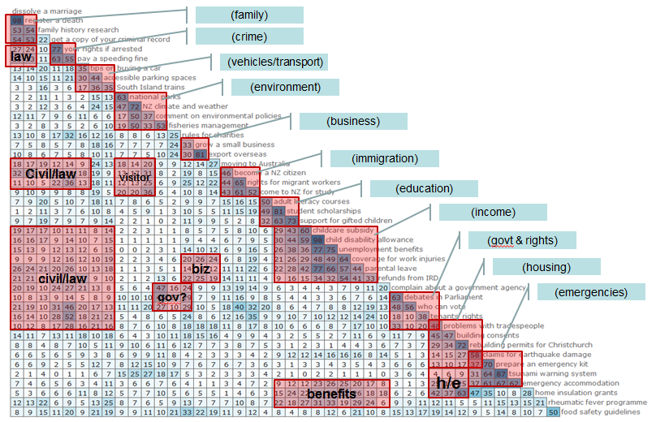
Most participants grouped the cards by topic (e.g. health, jobs, education, etc.) rather than by audience (youth, seniors, Maori, etc.) or government agency (IRD, WINZ, etc.).

Analysis of various participants groups (e.g. government vs. non-government employees, etc.) revealed no large differences in their groupings. This suggests that a single site structure may work for most users.

Strong groups
There was widespread agreement about which content belonged in the following groups:
- Benefits
- Births, deaths, marriages
- Housing/building
- Business
- Emergencies/disasters
- Crime/police/justice
- Education
- Environment
- Health
- Immigration/emigration
- Transport

Weaker groups
While the following groups were popular, they were “fuzzier”. That is, there was less agreement about which cards belonged in which group:
- Families
- Finance
- General/misc
- Government
- Law/legal
- Living in NZ
- Rights
- Social services
- Work

Representative sorts
The following sort was the most representative:

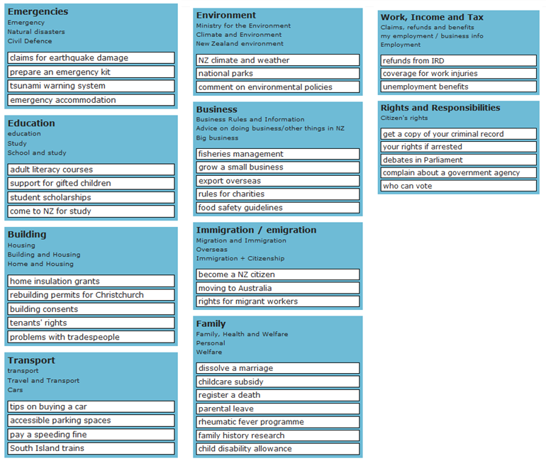

More details
For details of the card sort, including cards used, participant profiles, and detailed results with visualisations, see the OptimalSort tab in the online DIA account for Optimal Workshop.

TREE TESTING

Round 1

Baseline tree (existing site)
The overall success rate was 62% - a respectable score for a tree of this complexity. This suggests that, in terms of browsing, the site is doing a decent job of helping users find the information they need.

Top findings:
- The term "community" at the top level (“Families & communities”) implied local government for many participants.
- Participants expected “Participate and be involved” to include contacts and complaints.
- “Tourism & travellers” was confounded with “Immigration” for many participants.
- Vague topics like “Social welfare & support” and “About New Zealand” attracted many unwanted clicks.
- Consumer-affairs content (such as the “advertising standards” task) did not have a natural home in this tree, and participants could not agree on where it lived.

“Straw man” tree
The overall success rate was 79% - a excellent score for a tree of this complexity. The lowest task scored 63%, indicating that there were no major problem areas for common or critical tasks.

Top findings:
- Because of phrasing, in the “Energy & conservation” section, “conservation” was interpreted by many participants as “energy conservation”, not “Dept. of Conservation” as intended. Revised in round 2.
- “Environmental management” was vague, with many participants going there for the “help maintain tramping trails” task. Revised in round 2.
- Topics that used “brand names” (e.g. “Heartlands”) without describing them (e.g. “Heartlands (rural access to government services)” caused problems.
- For existing hubs such as Health and Business, listing a few non-hub topics and a generic “see more topics” forwarding link raised the question of how these existing hubs should be represented in the overall site structure. For details, see page 16.
- Many participants did not understand the difference between the “A-Z of Government agencies and departments” and the “A-Z of government websites” topics.

“Exhaustive” tree
The overall success rate was 71% - a good score for a tree of this complexity. Two low-scoring tasks (42% and 33%) pinpointed weak areas to improve, and some differences in organisation and labelling from the “straw man” suggested useful revisions for round 2.

Top findings:
- “Coming to/leaving NZ” was a good label (clear and distinguishable) for topics involving immigration, emigration, and overseas travel in general.
- “Communications” (a short form of “Internet, media, and communications” in the straw-man tree) attracted unwanted hits for complaints (as in “communicate with the government”). We recommend that this term should not be used on its own.
- The top-level “Consumer affairs” topic worked well.
- Topics like “Support services” (in the Families section) and “Services - rights and advice” (in the Consumer Affairs section) attracted unwanted traffic. We recommend avoiding the term “services” where possible, unless it is qualified with specific terms.
- “Culture” was a useful umbrella term that also captured “history and heritage” traffic.
- The “Government – about” top-level section was too vague, and attracted a steady stream of clicks for unrelated tasks.
- The “Specific audiences” top-level heading (seniors, Maori, etc.) did not get much traffic, but this was likely more because of its placement at the bottom of a long list and its problematic labelling.
- Even in the context of “Research, science, & technology”, some participants were attracted to “research” for the genealogy task.

Round 2

“Straw man” tree (v2)
The overall success rate was 79% - a excellent score for a tree of this complexity. The few low-scoring tasks are easily handled by minor tree revisions, which would push the overall success rate beyond 80%.

Despite the size and comprehensiveness of the “straw man” tree, participants were able to find most items as quickly as easily as they could in the “minimal” tree (below). But because the “straw man” will be more likely to be able to handle new types of content as they get added over time, we recommend it over the minimal tree in general.

Top findings:
- Participants were split between being topic-focused (e.g. go to Passports, then look for a way to complain) and action-focused (look for Complaints right from the start). We recommend that key items be linked from more than one place, or at least offer “see also” links between related topics and actions.
- For tasks involving legislation (looking up laws and codes), Crime & Justice is the magnet topic. It should include a level-2 link to legislation (possibly via the legislation.govt.nz hub?).
- For tasks involving anything local (e.g. a proposed motorway, accessible parking), participants looked for local government, in both the Contact Government section and in the Community, Arts, & Recreation section. The latter should redirect them to the former.
- The Business topic needs more thinking and research. Do we intend this to be for consumers or for business? The current business.govt.nz hub seems designed for the latter, but that may not fit our intent (except for self-employment).
- In several sections (e.g. Environment), the third level was too abstract for many participants. We recommend focusing on concrete content, quick answers, and plain-English services, and refer users looking for more detailed things elsewhere. More focused studies (e.g. card sorts on subsections) would help determine the right structure and labels for this content.
- Similarly, the Health section should focus on popular topics, quick answers, and emergency phone numbers, referring users to the health.govt.nz hub for more detailed information.
- The Coming to NZ and Leaving NZ sections worked well, and could be safely combined if needed by other factors (such as visual-design constraints).
- For consultations, many participants went to the subject area first, or looked for local councils (both reasonable choices), but some participants did not understand the term “consultation” itself. This is “government speak” that will need explaining. It also needs to be distinguished from generic “feedback”.
- Consumer Rights was not discoverable enough under Money & Tax. Some looked for it under Business, but considering its importance (government plays a major role in protecting consumers, monitoring and regulating business), making it a top-level section (as it was in the “exhaustive” tree) may be warranted.
- Other hubs such as newzealand.com (Tourism), beehive.govt.nz, and Te Ara provide different “views” of NZ government information for different audiences, but more research is needed to determine how these fit into the big picture.

“Minimal” tree
The overall success rate was 73% - a good score considering the intentionally limited scope of this tree.

Top findings:
- Contacts & Feedback was an “evil attractor”, luring traffic when it was not appropriate. It needs to be more specific to avoid unwanted hits.
- The combined “Coming to NZ / Leaving NZ” heading worked well, and proved a good way to consolidate top-level topics.
- Many participants had trouble finding the right answer in the Driving section. We recommend reorganising this section to offer more choices at the second level.
- For the “jury duty” task, most participants went correctly to Crime & Justice, but (for want of a suitable subtopic) ended up going to Legislation, which would be a hard slog in most cases. We recommend adding a Courts section to handle the most common interactions that citizens have with the legal system.
- As in the “straw man” tree, Consumer Rights was not discoverable enough under Money & Tax.

More details
For details of the tree tests, including trees used, tasks, participant profiles, and detailed results with visualisations, see the Treejack tab in the online DIA account for Optimal Workshop.

PROPOSED SITE STRUCTURE
Based on the results of card sorting and 2 rounds of tree testing, the original “straw man” site structure has been revised to the following top-level sections:
- Business
- Community, arts and recreation
- Government in NZ
- Consumer rights
- Crime and justice
- Driving and transport
- Education and training
- Emergencies and disasters
- Environment and energy
- Families
- Health
- History and heritage
- Housing and property
- Internet and communication
- Money and financial support
- Travelling or moving overseas
- Visiting and moving to NZ
- Work and jobs

It explicitly excludes the following content:
- Economy and trade (not targeted at the general public)
- Research, science, and technology (not targeted at the general public)
- About NZ (too general)

IA PRINCIPLES
In analysing card-sort results, developing several alternative site structures, and refining them with tree testing, the following general principles have emerged:

Finalised principles

 | Principle | Rationale/Details
 | Organise mainly by topic. | Based on card-sort results and other government sites that tested well, topics (e.g. Families, Jobs) are more effective for browsing than audience, government agency, etc.
 | Define the top 2 levels. | Level 1 topics are solid (both organisation and labels). Level 2 topics are mostly there but some need more attention. Level 3 topics are indicative, but need closer attention by people versed in those subject domains.
 | Consider the order of topics. | Level 1 topics do not have a natural order, so alphabetical makes the most sense.  For level 2 and 3 topics, use logical order where possible, followed by frequency of use. Alphabetical is usually a last resort.
 | Aim for 4-10 topics at lower levels. | Narrow, deep subtrees make for tedious browsing and tougher choices. Only subgroup where the list gets too long or there is a natural separation of topics.
 | Avoid general or ambiguous terms. | These attract unwanted hits. For example, "Support services" could include almost anything.
 | Avoid (or explain) brand names. | Write in plain language, not in government speak. For example, "Heartlands" becomes "Heartlands (rural access to govt)".
 | Make every word earn its keep. | At high levels, esp. level 1, each word needs to add meaning or coverage. Trim words that don’t. For example, “Family & whanau” >> “Family”.
 | Put content where most people look for it, but provide a safety net. | Where content can live in several places, put it in the bucket where most people look (based on testing), and add cross-links from other (less likely) places.

Tentative principles that need more research

 | Idea | Details
 | Scope - selective or exhaustive? | A selective scope (doing a good job curating a small garden of common/critical/high-value content, then growing it gradually) seems a good way to start.  However, in user testing, participants were uncomfortable with the idea of a limited scope. They wanted a single site where they could be confident looking for anything government-related. Tree testing showed that a comprehensive tree could work as well a minimal tree for findability. And future content is more likely to fit into a comprehensive tree than a minimal one.
 | Existing hubs - how to handle? | For existing hubs like Business and health, there are (at least) 3 options:  - List the hub’s main headings as level 2 headings in the big tree.  - List the top items (from the hub and other sources), then add an “all other topics” item to redirects to the hub itself.  - List top items from other sources (NOT in the hub), then add an “all other topics” item to redirects to the hub itself.  Option 2 is likely the best choice, but this will depend largely on how the hub is organised.
 | Alternative portals for special cases? | Providing alternative ways to browse (e.g. A-Z index of agencies, by audience (seniors, youth, Maori, etc.)) can be useful, but does add effort to implement and maintain.  A-Z of agencies – Useful, straightforward, and expected. Do this in the first phase.  By audience - Consider doing these based on demand, likely in a later phase.

